MUJTABA SHAHID FAIZI
BSCS-5A
#131818
LAB 12 OF OS

Task 1:

Code:

#include<stdio.h>
#include<unistd.h>
#include<stdlib.h>
#include <sys/types.h>
#include <sys/stat.h>
#include <unistd.h>
#include<string.h>
#include <fcntl.h>

int main(int argc,char *argv[])
{
int file_in,read_bytes,current_byte=0;
char current_char,line[1000];
int t_lines = 0,lines = 0;
if(argc != 3)
{
printf ("atleast 3 arguments req.");
return 1;
}

if((file_in=open(argv[2],O_RDONLY)) != -1)
{
while((read_bytes=read(file_in,&current_char,sizeof(char)))!= 0)
{
if(current_char!='\n') //indicates new line in the text file
{
line[current_byte]=current_char;
current_byte++;
}
else
{
t_lines++; //compute total no. of lines in text file
memset(line,0,sizeof(line));
current_byte=0;
}

}
}
close(file_in);

if((file_in=open(argv[2],O_RDONLY)) != -1)
{
while((read_bytes=read(file_in,&current_char,sizeof(char)))!= 0)
{
if(current_char!='\n')
{
line[current_byte]=current_char;
current_byte++;
}
else
{ lines++;
if(lines > t_lines - atoi(argv[1])) //total lines minus the user given lines
printf("%s\n",line);
memset(line,0,sizeof(line));
current_byte=0;
}

}
}
}
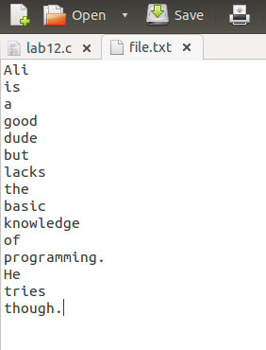

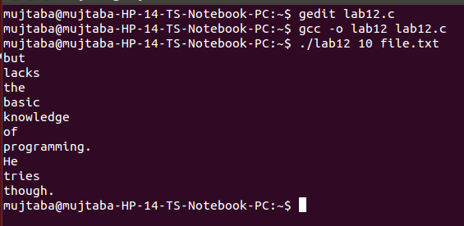

Task 2:

The following exercise examines the relationship between files and inodes on a UNIX or Linux system. On these systems, files are represented with inodes. That is, an inode is a file (and vice versa). You need to create two simple text files named file1.txt and file3.txt whose contents are unique sentences. Next, obtain the inode number of this file with the command “ls -li file1.txt”
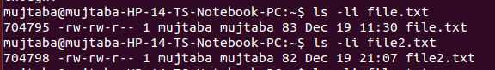

where the inode number is boldfaced. (The inode number of file1.txt is likely to be different on your system.). The UNIX ln command creates a link between a source and target file. This command works as follows: ln [-s] <source file> <target file>
UNIX provides two types of links: (1) hard links and (2) soft links. A hard link creates a separate target file that has the same inode as the source file. Enter the following command to create a hard link between file1.txt and file2.txt: “ln file1.txt file2.txt”
What are the inode values of file1.txt and file2.txt? Are they the same or different? Do the two files have the same—or different—contents?

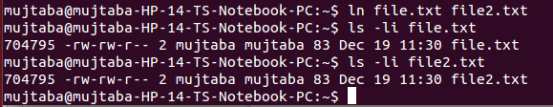
file.txt and file2.txt has same 704795 inode values as well as the same contents.
Next, edit file2.txt and change its contents. After you have done so, examine the contents of file1.txt. Are the contents of file1.txt and file2.txt the same or different?
same
Next, enter the following command which removes file1.txt: “rm file1.txt”
Does file2.txt still exist as well?
Still exists
Now examine the man pages for both the rm and unlink commands. Afterwards, remove file2.txt by entering the command “strace rm file2.txt”
The strace command traces the execution of system calls as the command rm file2.txt is run. What system call is used for removing file2.txt?
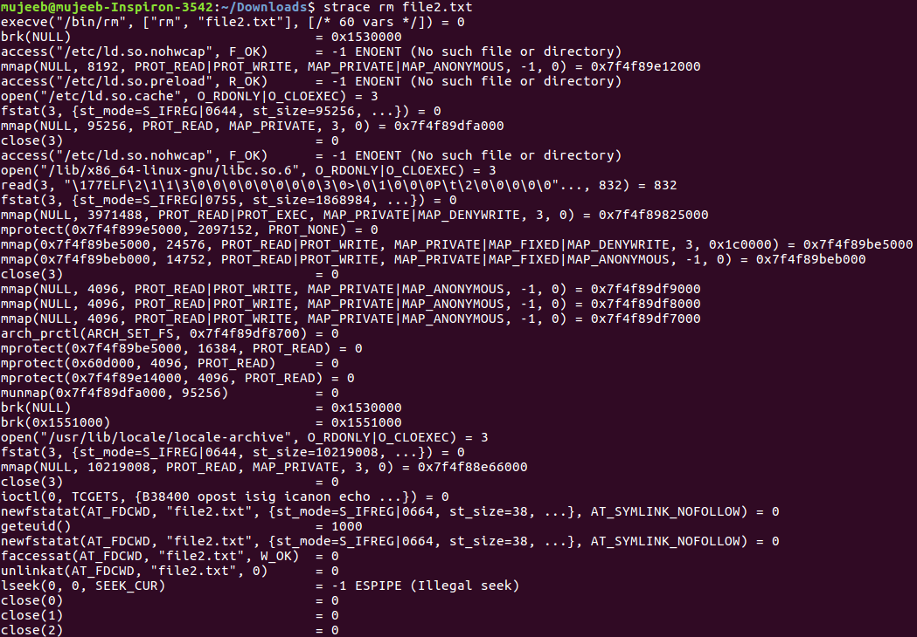
unlinkat(AT_FDCWD, "file2.txt", 0) = 0
After removing file2.txt “unlink” system call is being called.

A soft link (or symbolic link) creates a new file that “points” to the name of the file it is linking to. In the source code available with this text, create a soft link to file3.txt by entering the following command: “ln -s file3.txt file4.txt”
After you have done so, obtain the inode numbers of file3.txt and file4.txt using the command: “ls -li file*.txt”
Are the inodes the same, or is each unique?
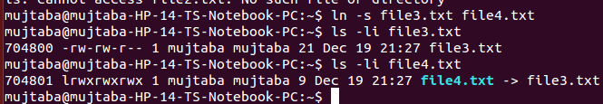

unique
Next, edit the contents of file4.txt. Have the contents of file3.txt been altered as well?
Yes
Last, delete file3.txt. After you have done so, explain what happens when you attempt to edit file4.txt
I’m unable to edit file4.txt as there was soft link between these two files.

